**Dataset used: - NOAA Lightning Strike (2009-2018)**

**These are some of the visualizations that I practiced along with some reference guides that can also serve as a set of usability reminders for you to recall when using Tableau in your future career.**

* Line and bar chart representing number of strikes from the year 2009-18 in United nations regions.

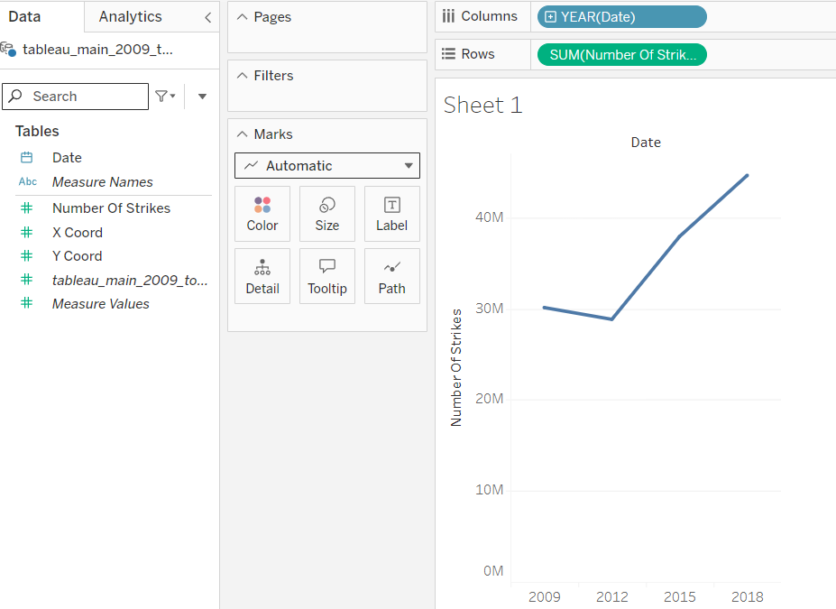

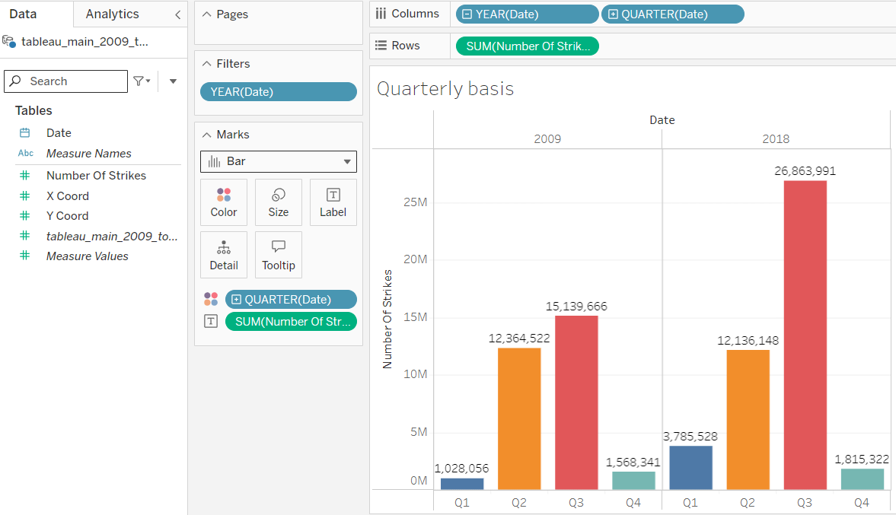

* The below is a geographic map of the location of lightning strikes in the U.S. in 2018.

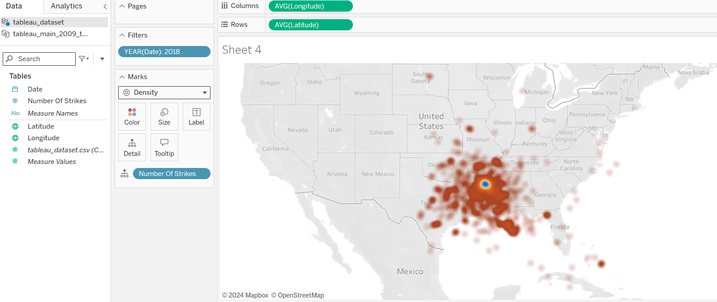

* Heatmap to visualize the magnitude of a measure i.e. number of strikes along two dimensions i.e. Year and Month.

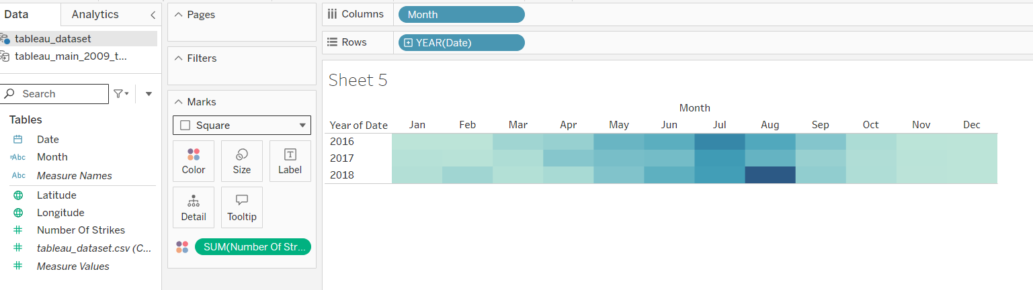

* A box plot and a histogram to understand the distribution of continuous variable and identify outliers.

